Waterfall model:
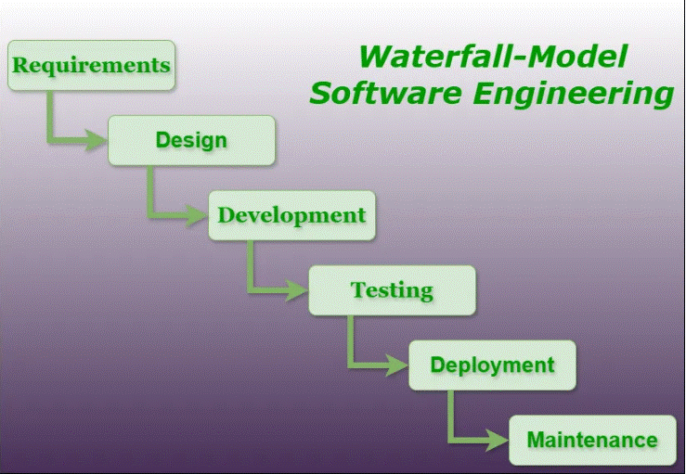
Requirements
Developing
Testing
Deployment
Maintenance
Above were done in a single iteration.
That is we cannot go back to the previous state that is why it is termed as waterfall model.
Requires extensive documentation.
Resistant towards changes.
suitable for simple projects.

Agile:
Instead of building the entire product at once, a simple version of the product is released in 1st sprint and based on the feedback it will be updated in further sprints.
Scrum: (an agile framework)
consists of 3 roles:
Product owner
Scrum master
Development team

Product backlog
Sprint backlog
potentially shippable product
Sprint review
Sprint retrospective
